Fan Control

Custom Project Final Report

Spring 2019

Esa Soudbakhsh

Table of Contents

[**Introduction**](https://docs.google.com/document/d/1-xy6VmtY8k6tF-gSGBFLczn0Hhce3uhBp-F_ejkmoHQ/edit#heading=h.n9o44neiquk5)[**2**](https://docs.google.com/document/d/1-xy6VmtY8k6tF-gSGBFLczn0Hhce3uhBp-F_ejkmoHQ/edit#heading=h.n9o44neiquk5)

[**Hardware**](https://docs.google.com/document/d/1-xy6VmtY8k6tF-gSGBFLczn0Hhce3uhBp-F_ejkmoHQ/edit#heading=h.vqmbsuo5p330)[**2**](https://docs.google.com/document/d/1-xy6VmtY8k6tF-gSGBFLczn0Hhce3uhBp-F_ejkmoHQ/edit#heading=h.vqmbsuo5p330)

[Parts List](https://docs.google.com/document/d/1-xy6VmtY8k6tF-gSGBFLczn0Hhce3uhBp-F_ejkmoHQ/edit#heading=h.xtqh2tzibtrr) [2](https://docs.google.com/document/d/1-xy6VmtY8k6tF-gSGBFLczn0Hhce3uhBp-F_ejkmoHQ/edit#heading=h.xtqh2tzibtrr)

[Pinout](https://docs.google.com/document/d/1-xy6VmtY8k6tF-gSGBFLczn0Hhce3uhBp-F_ejkmoHQ/edit#heading=h.8yptvhjzojq8) [3](https://docs.google.com/document/d/1-xy6VmtY8k6tF-gSGBFLczn0Hhce3uhBp-F_ejkmoHQ/edit#heading=h.8yptvhjzojq8)

[**Software**](https://docs.google.com/document/d/1-xy6VmtY8k6tF-gSGBFLczn0Hhce3uhBp-F_ejkmoHQ/edit#heading=h.w9543qe124on)

Examples of Program:[**3**](https://docs.google.com/document/d/1-xy6VmtY8k6tF-gSGBFLczn0Hhce3uhBp-F_ejkmoHQ/edit#heading=h.w9543qe124on)

[**Complexities**](https://docs.google.com/document/d/1-xy6VmtY8k6tF-gSGBFLczn0Hhce3uhBp-F_ejkmoHQ/edit#heading=h.sn48u4uktu3c)[**3**](https://docs.google.com/document/d/1-xy6VmtY8k6tF-gSGBFLczn0Hhce3uhBp-F_ejkmoHQ/edit#heading=h.sn48u4uktu3c)

[Completed Complexities:](https://docs.google.com/document/d/1-xy6VmtY8k6tF-gSGBFLczn0Hhce3uhBp-F_ejkmoHQ/edit#heading=h.tp9dnsse4u9p)

[**Known Bugs and Shortcomings**](https://docs.google.com/document/d/1-xy6VmtY8k6tF-gSGBFLczn0Hhce3uhBp-F_ejkmoHQ/edit#heading=h.grlzpb6vy2cq) **4**

[**Future work**](https://docs.google.com/document/d/1-xy6VmtY8k6tF-gSGBFLczn0Hhce3uhBp-F_ejkmoHQ/edit#heading=h.qbv6f31drpex)[**4**](https://docs.google.com/document/d/1-xy6VmtY8k6tF-gSGBFLczn0Hhce3uhBp-F_ejkmoHQ/edit#heading=h.qbv6f31drpex)

Introduction

The temperature controller activates on terms of pulse width modulation that outputs within the range of values received by a sensor input. The probe can either be a thermistor, a photoresistor, or a varistor that allows a specific amount of voltage to be detected by the pin on the ATmega1284 microcontroller. Moreover, analog to digital conversion results in a 10-bit binary encoding with the maximum decimal value of 1024. Although a temperature sensor such as an LM35 would be most rational for the use of the controller, a photoresistor exhibits the most flexible range of values due to its sensitivity in detection of ambient source. Pulse width modulation is utilized to monitor the functionality of the fan by setting the frequency according to the ADC value that was received from the probe on PA0. The modes of output are low, medium, and high which gives the amount of power to the fan respectively. The LCD displays the mode and the digital value of the probe. The program for the overall project is formatted in a concurrent state machine with a task for the ADC, PWM, and the LCD. The period was initialized to 100 ms for both the PWM and the LCD while the ADC task required 500 ms for a steady reading of input values.

Hardware

Parts List

* ATmega1284
* LED
* Fan
* LM35
* Photo resistor
* LCD

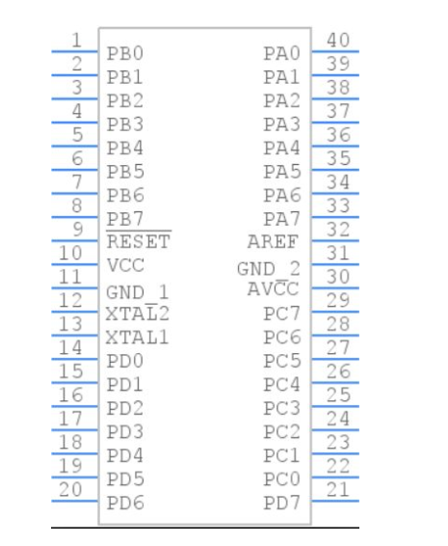

* LCD PD0-PD6
* Component Sensor PA0
* Button PA1
* Fan PB0

Software

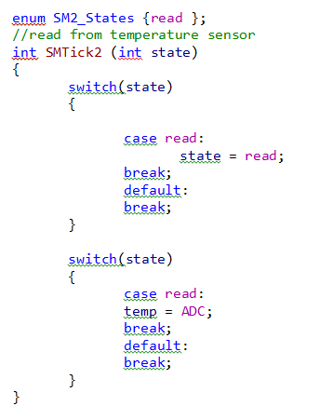

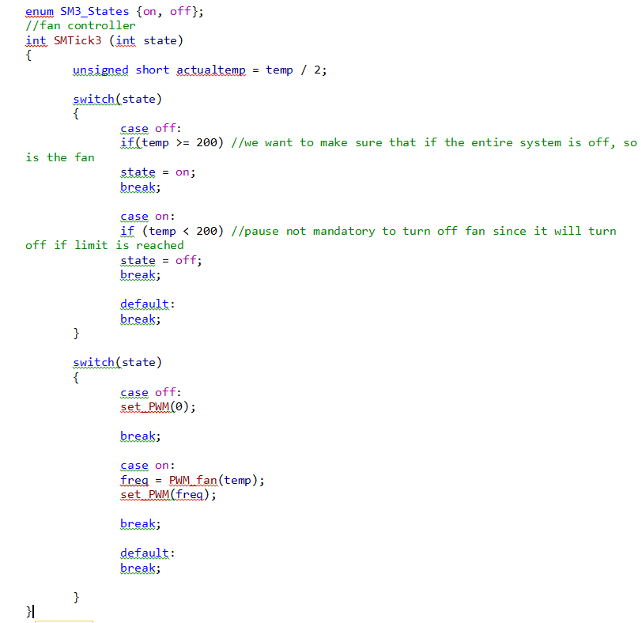

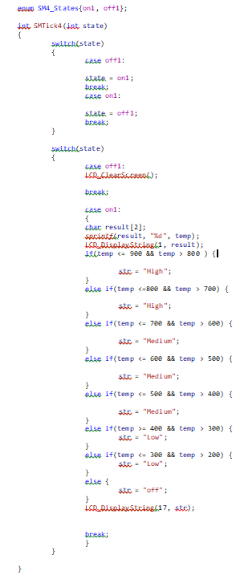

Complexities

Completed Complexities:

* Using ADC from various sensor inputs
* Using PWM to power on device circuitry
* Concurrent state machines to implement overall project

Known Bugs and Shortcomings

* The fan was purchased at low cost therefore sometimes does not meet the highest quality of expectations for the outputting PWM. The fan requires a slight spin in order to have enough energy to begin its cycles.

Future Work

Additional features to the Fan Control project could potentially include an ultrasonic component to detect motion for safety so that the entire system powers off if an object is detected within a certain distance. I would also add another feature that allows the user to interact with the device to manually turn on the system without needing an automatic reception from a probe.